Western Kentucky University Selected to Host Local Qualifier
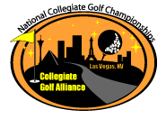
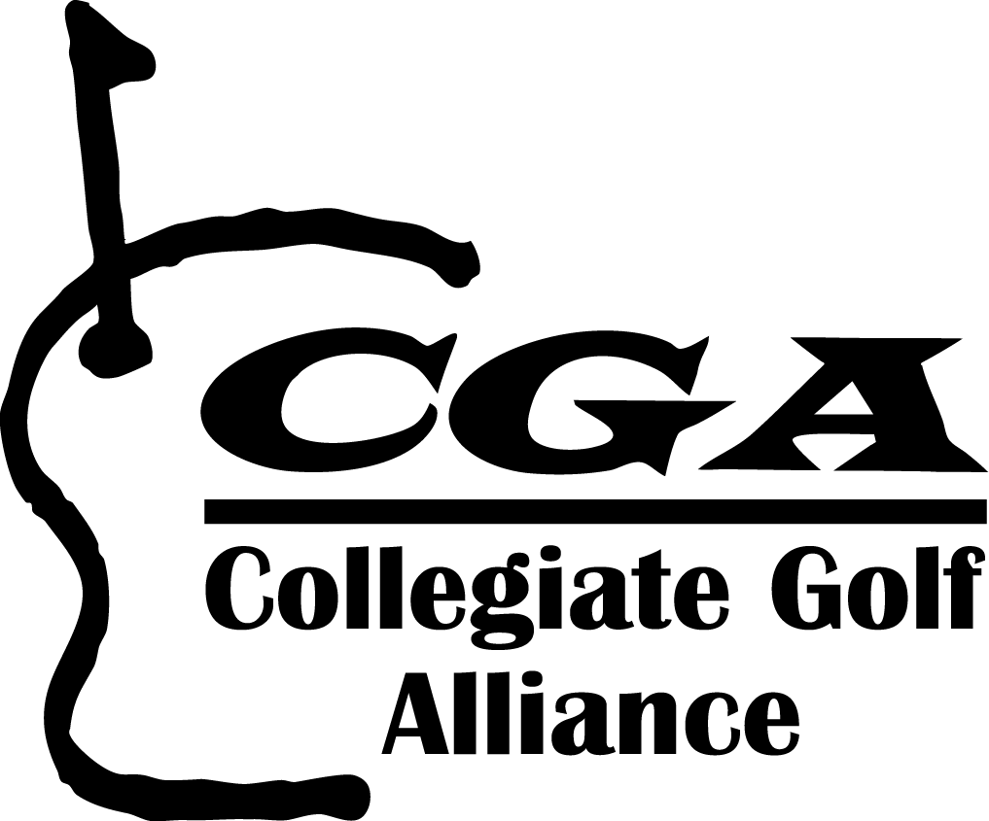
2012 National Collegiate Golf Championship
October 2nd, 2012 Crosswinds Golf Course

For Immediate Release
September 5, 2012
www.cgagolflinks.com
info@cgagolflinks.com

In partnership with National Intramural-Recreational Association
Supported by the PGA of America

Irvine, CA (April 28, 2012) Collegiate Golf Alliance (CGA), the premier online golf registration and event management company, announced Western Kentucky University will be one of 50 local qualifying host schools for the 11th Annual National Collegiate Golf Championship. The California-based company will team with the National Intramural-Recreational Sports Association (NIRSA) to manage the 2012 National Collegiate Golf Championship. A 2 person scramble event for collegiate and university amateurs, the NCGC will allow golfers to compete for their university to see who will be the 2012 National Champion. The Championship has three divisions: Student, Faculty/Staff and Alumni/Community. All levels of golfers are encouraged to participate. The Western Kentucky University Local Qualifier will be held on October 2nd, 2012 at Crosswinds Golf Course. An On Campus expo will be held on the Western Kentucky University campus to promote the program. For more event info contact Stephen Rey steve.rey@wku.edu 270-745-6060 and for a listing of all Local Qualifiers, dates and courses go to http://www.cgagolflinks.com/ncgc.asp

This amateur golf event is focused on university recreational golfers and will consist of 50-60 local qualifying tournaments held across the United States in the summer and fall. Local qualifying winners will advance to the official National Collegiate Golf Championship in Las Vegas, November 9-11, 2012. The CGA and NIRSA will jointly promote and market the event to over 750 colleges and universities. Over the past ten years the NCGC programs has benefited the NIRSA Foundation, a not-for-profit organization that provides opportunities for students through professional development, research, scholarships, and educational resources.

Sponsors of the event include NIKE Golf, Golfsmith, Cutter & Buck, Techno Gym, American Hole in One, Advantage Fitness Products, First Tee Energy Bars, Precore and Golf Digest. To provide additional resources, CGA has appointed six regional managers to assist in the programming of campus golf events as well as help coordinate the National Tournament.

All Local Qualifier participants receive a prize package valued at over $550/school and $50/player that includes a $10 GolfSmith Gift Card, year subscription to Golf Digest or Golf World and numerous contests and additional prizes.

Participants also have the opportunity to advance to Las Vegas by placing in the top three in their division.

“As a competitive golfer in high school, I thought my time to compete in high-level golf tournaments was over when I enrolled at Marquette University. But upon arriving in Las Vegas, Nevada, to play in the National Collegiate Golf Tournament, I realized that absolutely was not true. From the beginning, my partner and I were treated like real competitors” said John Borneman Marquette University
Sponsors of the event include NIKE Golf, Golfsmith, Golf Digest, Cutter & Buck, American Hole in One, “The thrill of representing and competing for your university is now available to thousands of Students and Alumni. The opportunity to advance and compete for a National Championship is a tremendous experience and a memory that will last a lifetime.” Stated CGA’s President and CEO Mike Munson.

For more information please contact info@cgagolflinks.com, call (413) 332-6038 or go to www.cgagolflinks.com.
------------
Join us, follow us, look at us, watch us
CGAGolf


